1. 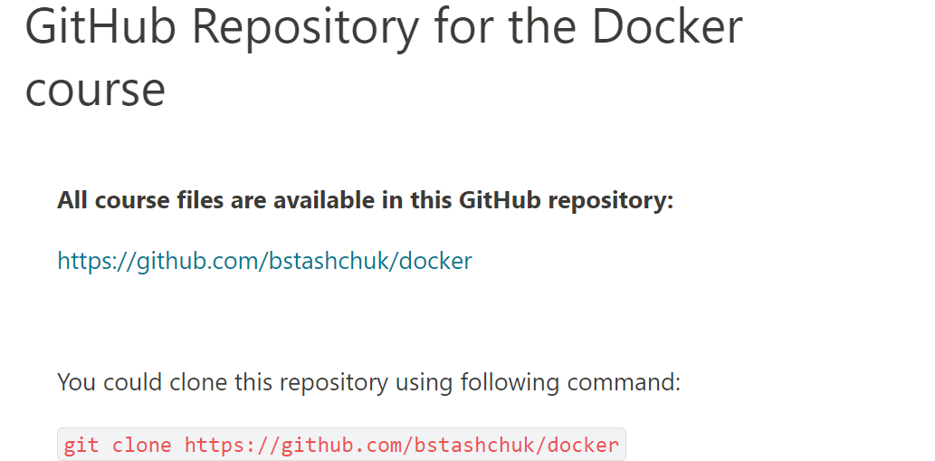

<https://github.com/bstashchuk/docker>

You could clone this repository using following command:

git clone https://github.com/bstashchuk/docker